A low cost sub-pico ampere source and measure fixture for demonstrating
the Keithley 6430 sub-femto amp sourcemeter.

Taking stable and accurate current measurements below 1 nA requires a guard shield (Faraday cage) as per the below excerpt from the 6430 reference manual:
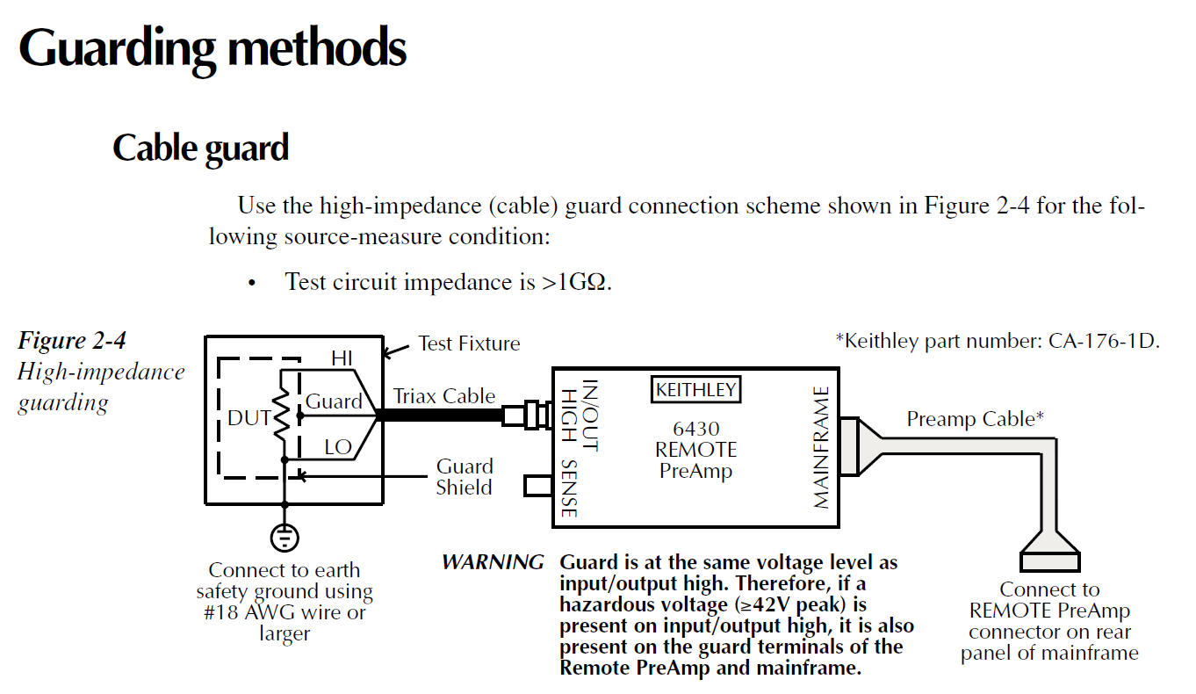
It was desired to measure currents below 1 pA. A 1T resistor was selected. The voltage used was 0.5V making the current below 0.5 pA.
A simple and inexpensive implementation was devised. The national chain dollar stores sell baking pans in a 3-pack that measure approximately 6” wide x 9” long x 2” high. The resistor is place at the end of the high and low alligator clips. The guard alligator clip is attached to the bottom baking pan. The DUT is suspended inside the enclosure using the stiffness of the cable’s end. Most or all of the unshielded cable and clips are inside the enclosure as pictured below.
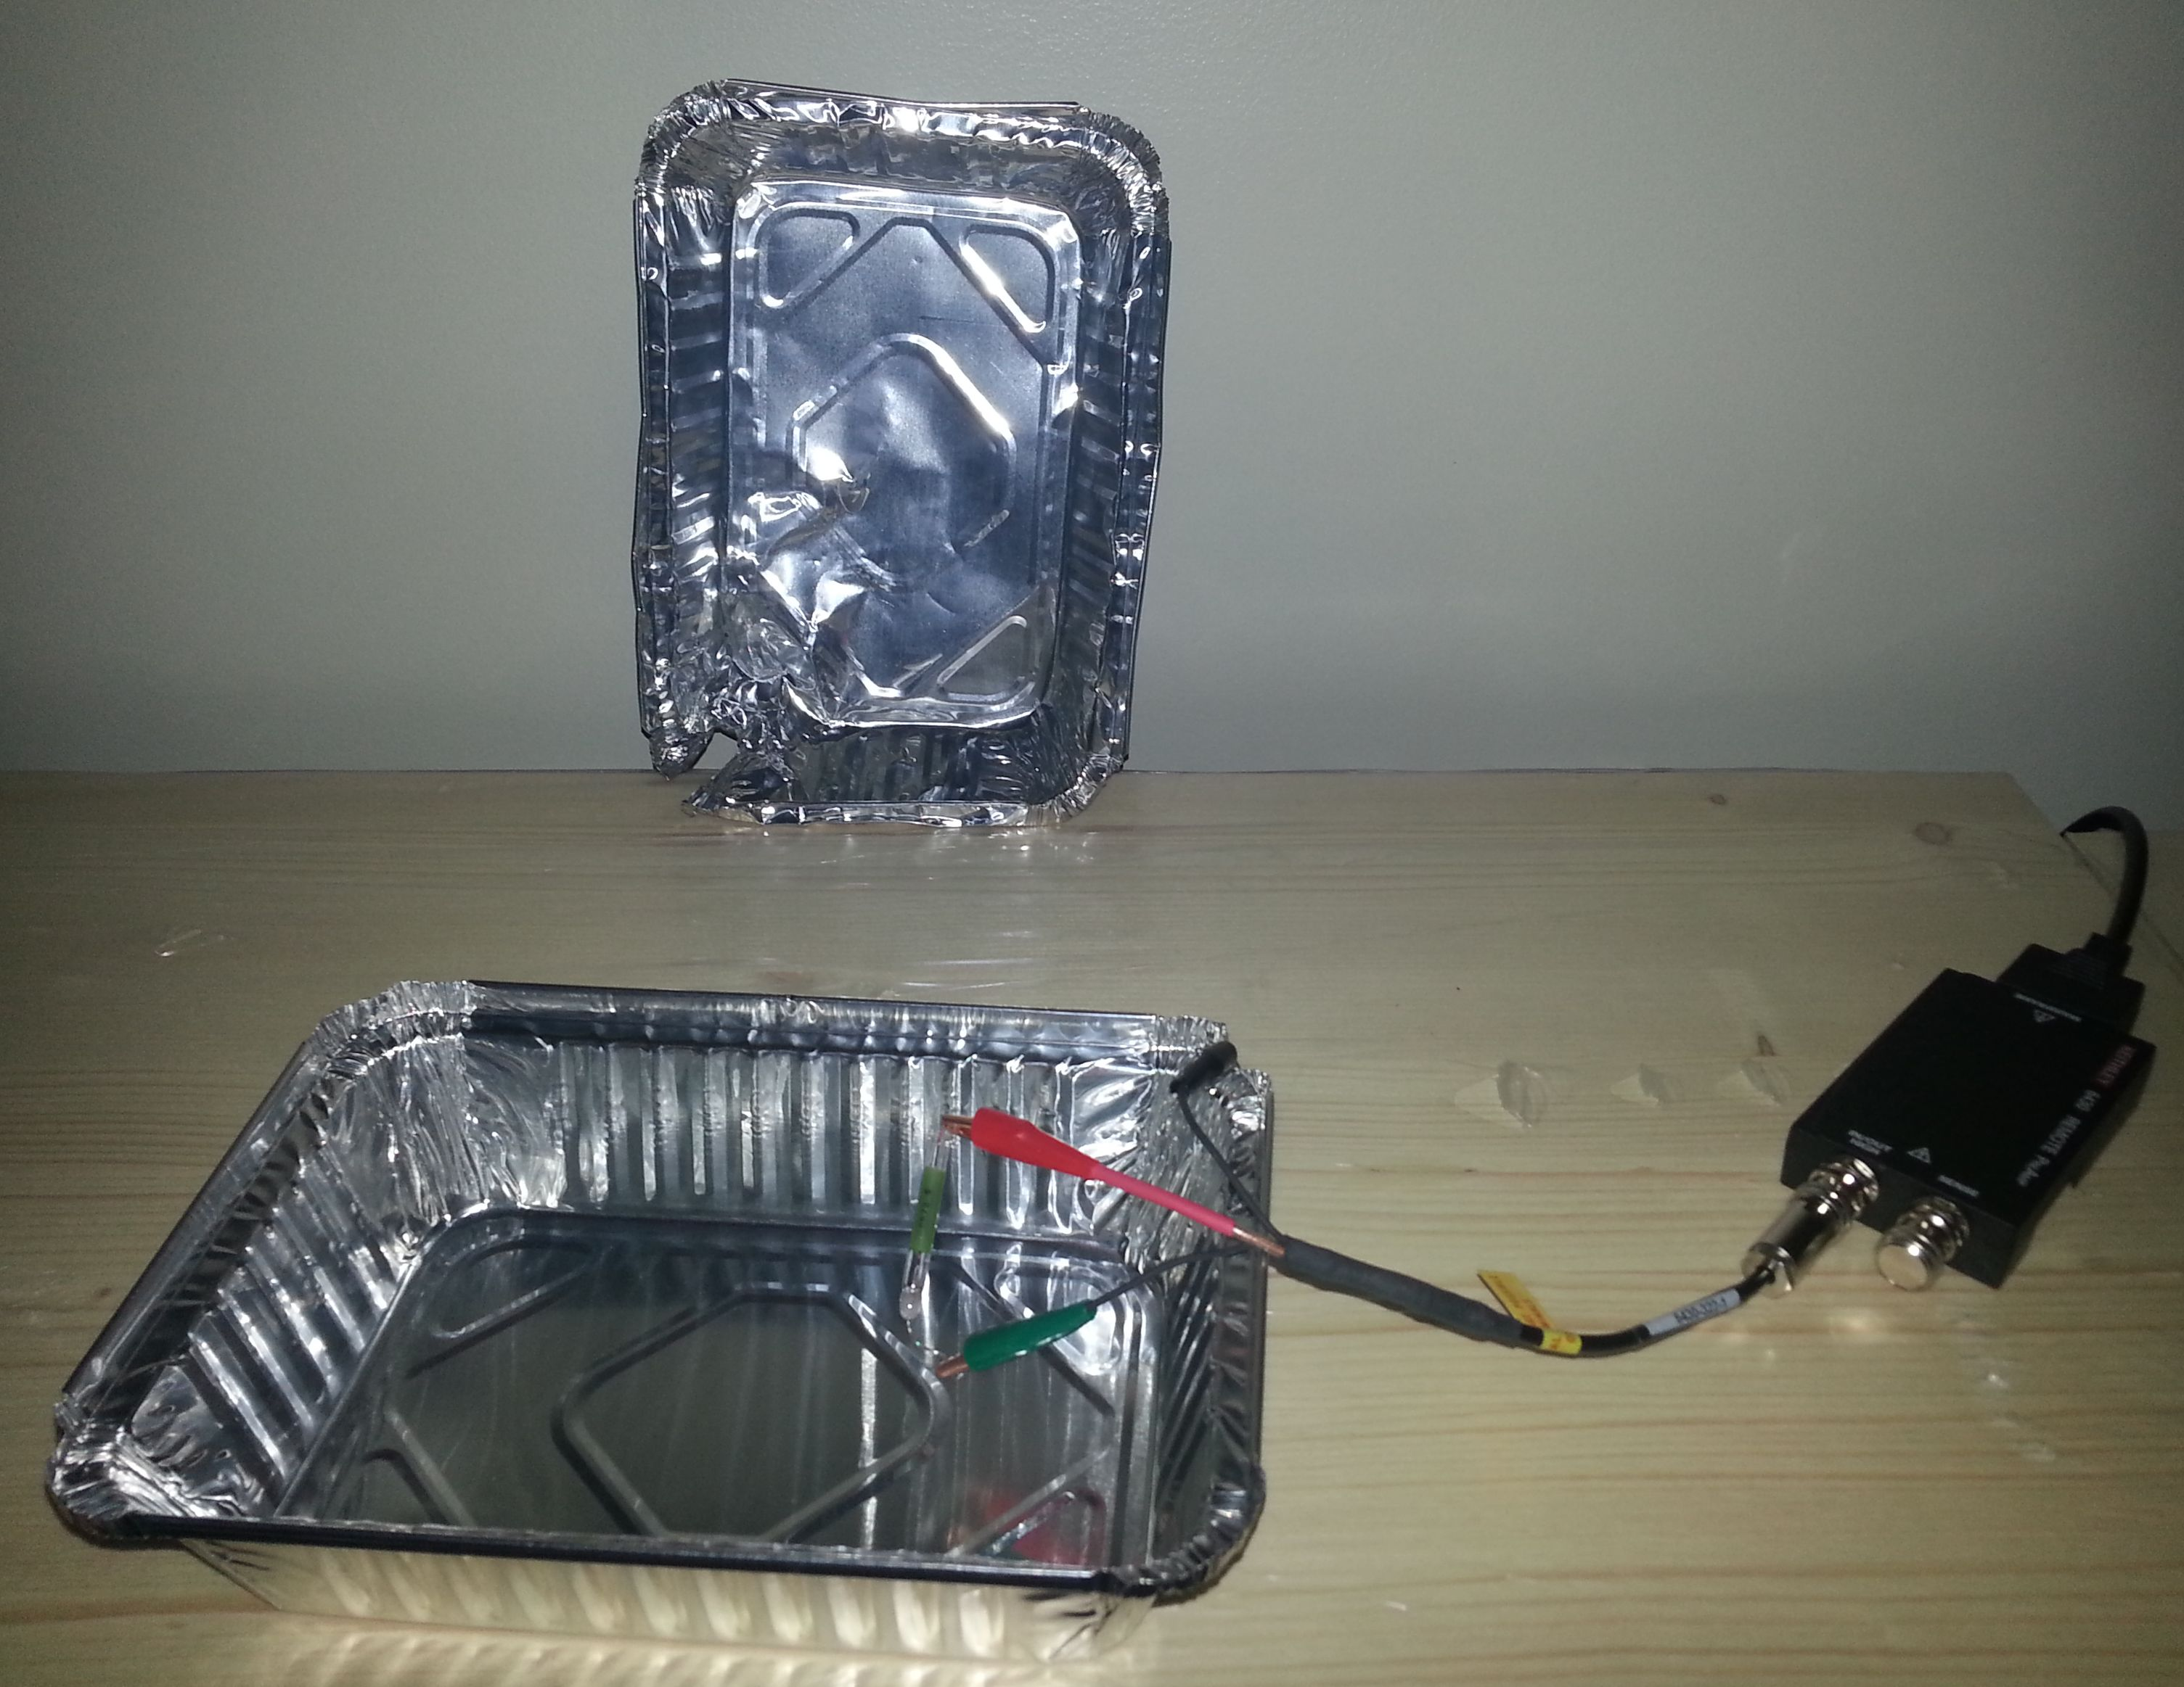
The top pan is placed upside down on top of the bottom pan as pictured below.
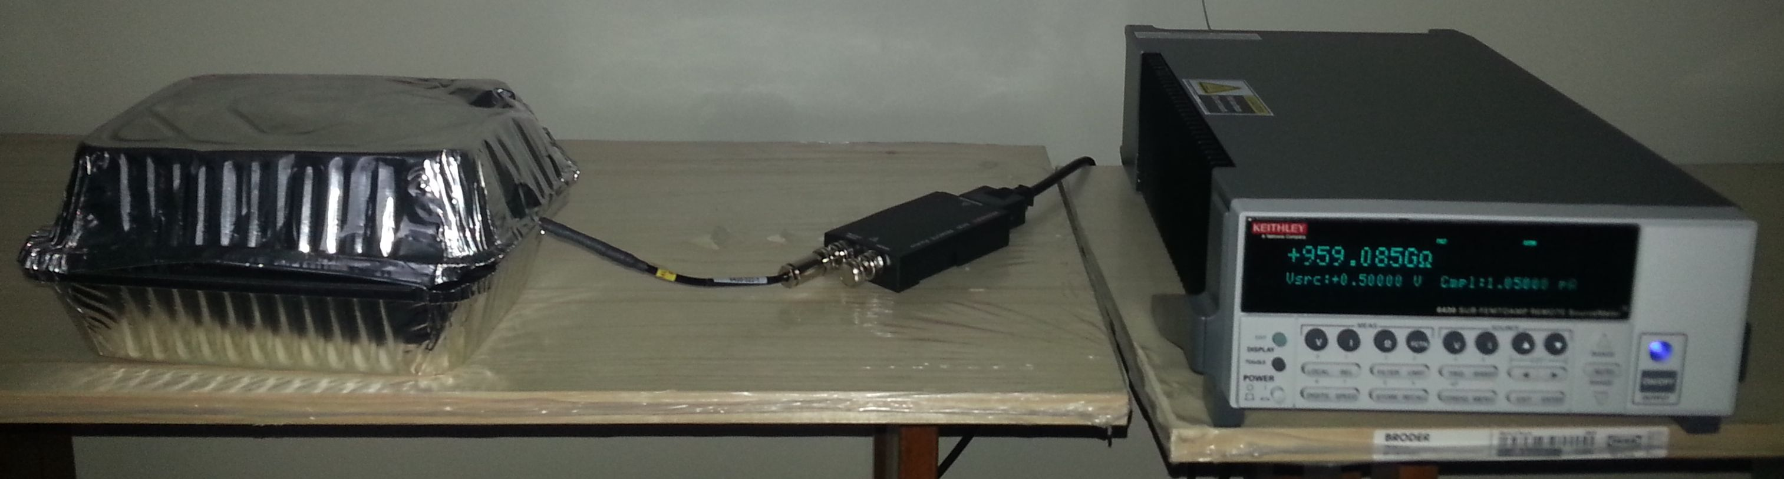
The instrument is set to source 0.5V. The current limit is set at 1.05 pA. The filter is configured for maximum NPLC and maximum readings averaged. The speed is set to maximum accuracy. Leave the filter off.
Turn the output on. The reading will wander until all of the residual charge on the enclosure is bled off and the enclosure is charged to the potential of the DUT. This can take many seconds to a couple of minutes. Be patient.
When the reading settles to +/- a few %, turn on the filter and wait for the reading to become better than +/- 1%. For the 1T DUT selected, the reading is about 958 G ohm +/- 1 G ohms. That is about 0.1% uncertainty. The total cost of the enclosure is $1.
This solution can be easily transported and used at a customer site.

